ECEN 4/5632 Theory and Application of Digital Filters Fall 2026
9-26-26 P. Mathys

Problem Set 6
1. Conv1d and the sliding dot product
Given the DSP convolution sum $y_{DSP}\left[n\right]=\sum_{k}{h\left[k\right]x[n-k]}$ and PyTorch’s cross-correlation convention $y_{torch}\left[n\right]=\sum_{k}{w\left[k\right]x[n+k]}$:
(a) Derive the relationship $w\left[k\right]=h[M-k]$ (where $h$ has $M+1$ taps, indices $0,…,M$) that makes F.conv1d reproduce the textbook causal FIR convolution, and state the required left-padding amount.
(b) Implement both, the NumPy convolution np.convolve and the equivalent F.conv1d computation for a Hamming-windowed FIR lowpass filter with $ω_{c}=π/3$ and length $N=51$ on a chirp signal (chirp_001.wav). Report the maximum absolute difference between the two outputs (you should get something on the order of ${10}^{-6}$ to ${10}^{-7}$ in float32). Show all your Python and PyTorch code in your solution.
(c) A colleague says “PyTorch’s conv1d does convolution backwards, so it’s a bug.” Give a one-paragraph rebuttal, using the ML viewpoint discussed in lecture.
2. Pole-zero geometry
For
$$H\left(z\right)=\frac{1-0.8z^{-1}}{1+0.5z^{-1}}$$
(a) Identify the zero and the pole.
(b) Explain geometrically why $\left|H(e^{jω}\right)|$ is the product of zero-vector lengths divided by the product of pole-vector lengths.
(c) Predict qualitatively whether the magnitude is larger near $ω=0$ or $ω=π$.

3. Phase delay and group delay
Let $H\left(e^{jω}\right)=\left|H\left(e^{jω}\right)\right|e^{jϕ(ω)}$ with $ϕ\left(ω\right)=-3ω+0.4sin⁡(ω)$.
(a) Compute the phase delay
$$τ_{p}\left(ω\right)=-\frac{ϕ(ω)}{ω}$$
for $ω≠0$.
(b) Compute the group delay
$$τ_{g}\left(ω\right)=-\frac{dϕ\left(ω\right)}{dω}.$$
(c) Explain why the system is not linear phase.
4. First order allpass
For real $\left|a\right|<1$,
$$H_{ap}\left(z\right)=\frac{z^{-1}-a}{1-az^{-1}}.$$
Show that
$${|H}_{ap}\left(e^{jω}\right)|=1$$
for all $ω$. Locate the pole and zero and explain the reciprocal relationship.
5. FIR types I, II, III, and IV
For each case below, identify the FIR type and state any forced zeros at $ω=0$ or $ω=π$ ($N$ is the number of filter taps):
1. $N=9$, symmetric.
2. $N=8$, symmetric.
3. $N=9$, antisymmetric.
4. $N=8$, antisymmetric.
Then explain why a Type II filter cannot realize a high-pass response with non-zero gain at $ω=π$.
6. Four zero constellation
A real-valued linear-phase FIR filter has a zero at
$$z_{0}=0.7e^{j0.6}.$$
List the other zeros implied by real-valued coefficients and linear-phase reciprocal symmetry.

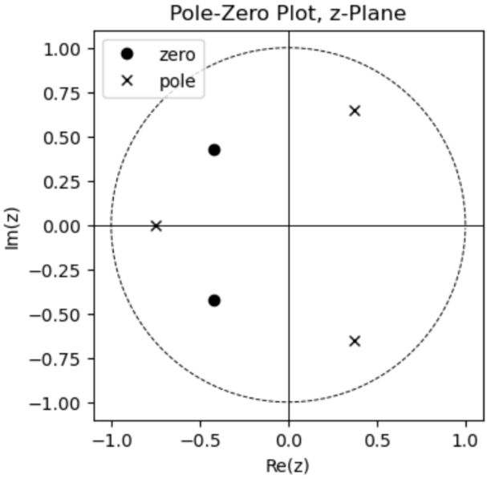
7. Inverse system properties (ECEN 5632 Problem)
If the system function $H(z)$ of an LTI system has a pole-zero plot as shown on the right and the system is causal, can the inverse system $H_{i}(z)$, where $H\left(z\right)H_{i}\left(z\right)=1$, be both causal and stable? Clearly justify your answer.

